GRFMaker User Guide:
Part 2: Creating a carriage
By James Vassie

Welcome all, to the second part in the guide to GRFMaker! In this section, I will deal with creating a passenger carriage.

First things first, open up the ‘example.lst’ file in GRFMaker; this is where we left off last time, with the creation of a passenger loco. We will now follow similar steps but to create a passenger carriage which can obviously carry passengers.

To start with, we need to make a label for the wagon, we do this by clicking on the Blue A, pictured:
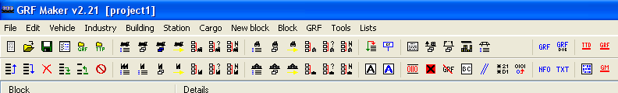
Now fill in the data so it looks like this:
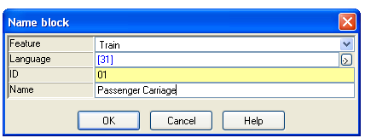
Next, we need to create and ID for the passenger carriage, containing its vital information such as introduction date and capacity. Click on the icon we used before to make a vehicle ID, pictured:
Then, we need to change the drop-down box to ‘Wagon’ because we aren’t making an engine; the only difference is the wagon ID has less stats that need filling in and slightly different ones. Change it and click OK.
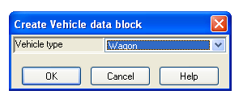
Double click on the new addition to the list of things in the .lst file, a popup box like the one below will appear.
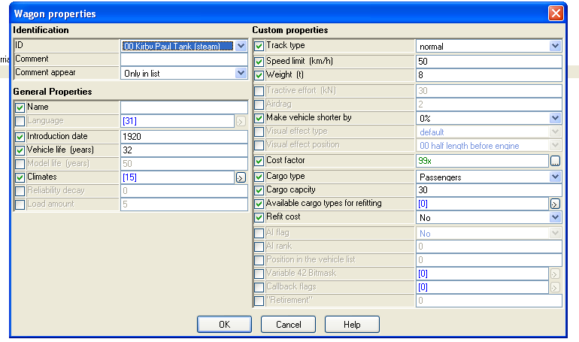
Now, very carefully change the details in this window so they resemble exactly the ones pictured below.
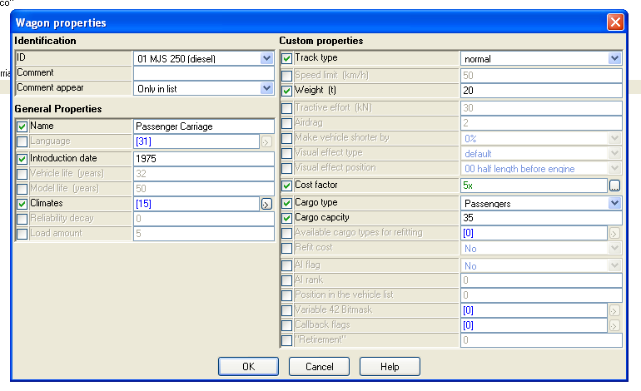
Wicked! Next thing to do is to add in the graphics we are going to use for this wagon. To do this we use the train engine with white boxes icon, pictured.
In the drop down box, change the info so it looks like this:
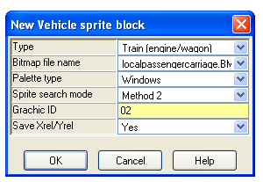
Then click ok. A screen like the one below will appear, using your middle mouse button (MMB) click on one of the sprites, they will all get a red box around them, as pictured below.
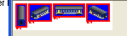
The next thing to do is align it, to use the defaults, click on ‘XYrel’ on the toolbar at the top and then choose ‘Set default values’, this will setup the loco so it’s near enough to the track to look acceptable, we can change these values at a later time. You will see the numbers below the picture change from -1’s into other numbers. On the mid-right we have some options to set… We can leave the first lot up until the greyed out ‘Action 2’ checkbox, click in the checkbox to un-grey it, and then select ‘Automatic’ from the two types. Then change the sprite/set to 4, as we only have 4 sprites. It should like the following window now, if so, please continue. Please click on OK at the bottom to continue.
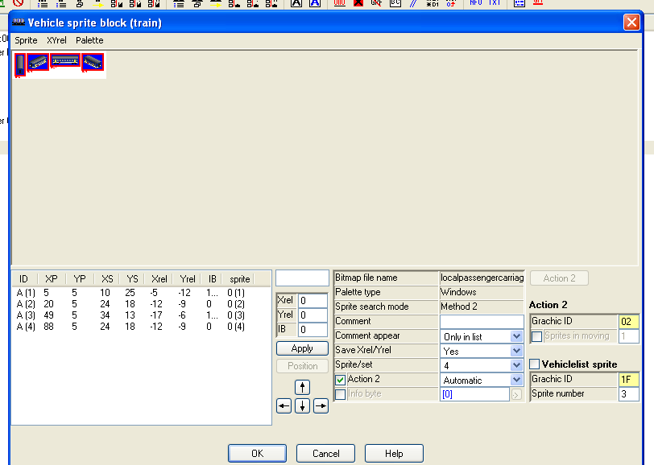
The main window should now look like this, if it doesn’t, then please go back and check you’ve don’t everything right.
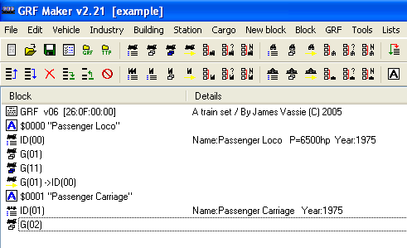
Next step is to create the depot graphics; this is done in a similar way to the passenger locos depot graphics. So now click on the little train icon with the blue boxes beneath it. Shown below:
A similar popup to the one before will appear… Choose the same file from the drop-down list and then type in 12 as the ‘Graphic ID’. Click OK. Double click on the line in the main window and select the sprite shown below using your Right Mouse Button (RMB):
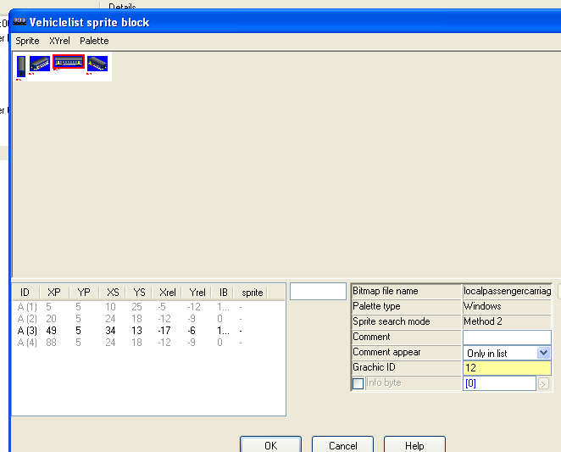
Click OK to go back to the main menu, one more step to go! That is we need to match the sprites and vehicle ID together, in a very similar way to the passenger loco. Click on the train icon with the little yellow arrow, pictured.
A window like the one below will popup, change the Engine to Wagon, for obvious reasons. Then click OK, and double click on the line on the main menu.
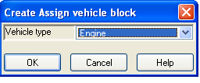
The screen you will get will be like this one:
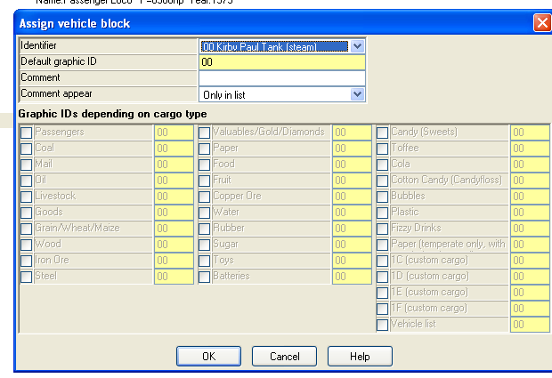
Next, we need to change the numbers here, so the ID is set to 01, the Default Graphic ID is set to 02 and the Vehicle List Sprite is set to 12, as shown.
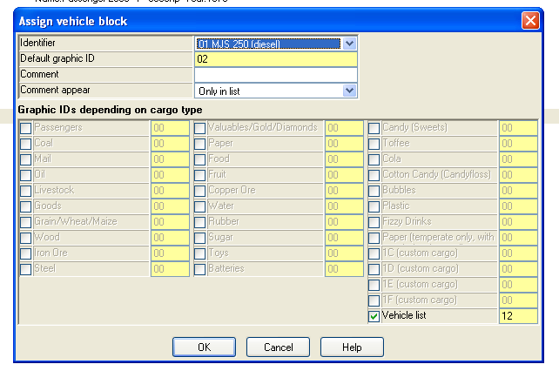
Yay! We are almost done now! Last step is to save, the .lst file, then to compile it into a GRF file. Once you’ve done that, you can test it to make sure it works! ☺ Please look at my future tutorials for further information on the usage of GRFMaker!

James Vassie

